RESEARCH STUDY - FEBRUARY 2026
AI FOR AMERICANS FIRST
AI Protectionism, Energy and Semiconductors: US/Europe Divergence Trajectories 2024-2030
Integrated Geostrategy and Economic Analysis - CHAPTER VI QUATER
76.9% of global operational AI compute = USA | 1.59x EU/US energy cost (PPP-adjusted) | 3.46:1 US/EU CACI ratio (Power Mode)

Fabrice Pizzi
Universite Paris-Sorbonne
Master 2 Intelligence Economique - Intelligence Warfare
Paris - February 2026 | 7 Chapters | 4 Prospective Scenarios | 3 Geographic Zones
Keywords: artificial intelligence, technological protectionism, semiconductors, export controls, sovereign compute, AI geopolitics, France, United States, China
CHAPTER VI QUATER
Consequences for Africa
Africa represents the next frontier of the AI economy. While the region currently has the lowest compute density in the world, its demographic potential and renewable energy assets make it a strategic terrain for the next decade. This chapter analyzes the impact of US protectionism on the African 'Compute Leapfrog', the infrastructure competition between the US and China, and the risk of a new digital divide.
6quater.1 The African 'Compute Leapfrog' challenge
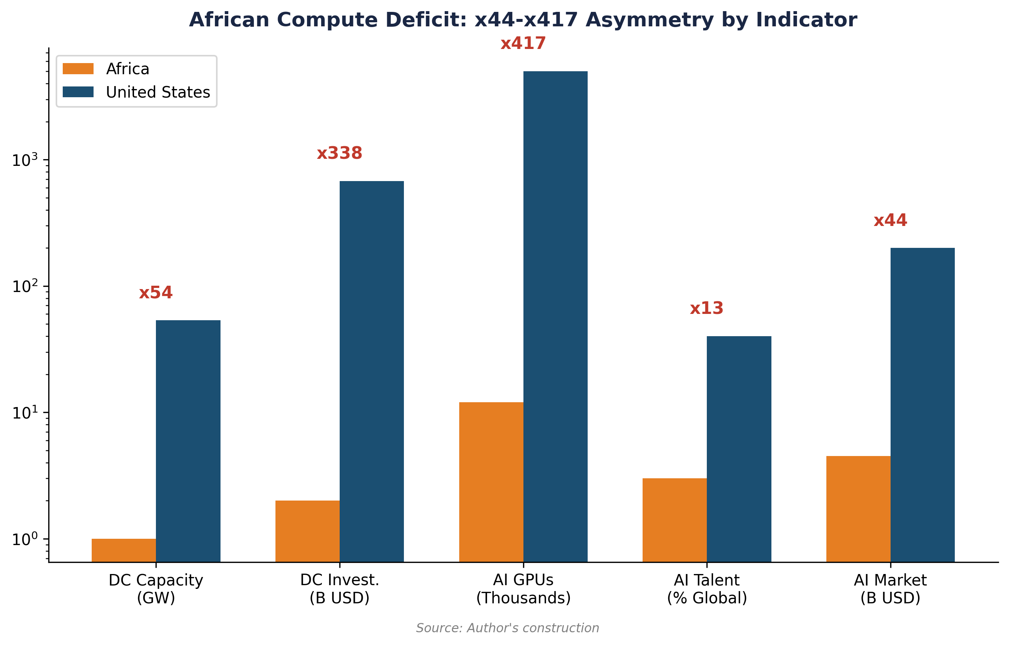

6quater.1.1 Infrastructure deficit and potential
Africa represents less than 1% of global colocation data center capacity in 2025.[1] However, the demand for local compute is exploding, driven by the digitization of financial services (M-Pesa, Flutterwave) and the need for model localization (African languages, specific socio-economic contexts). South Africa (Cape Town, Johannesburg), Nigeria (Lagos), and Kenya (Nairobi) are the primary hubs.
American AI protectionism (Tier 2 status for the entire continent) creates an entry barrier: African startups and governments have access to the US cloud, but building local sovereign infrastructure is hampered by GPU import caps and the high cost of capital. This reinforces a 'Cloud Dependency' that captures value toward US hyperscalers.


6quater.1.2 Renewable energy: Africa's comparative advantage
Like Brazil, Africa possesses massive renewable energy potential (solar in the Sahel, hydroelectric in Central Africa, wind in the Maghreb). Data center projects like the 'Green Africa Compute' initiative seek to use this energy to host sustainable AI infrastructure. However, the lack of transmission grids and the instability of the business climate remain major obstacles to attracting the necessary multi-billion dollar investments.


6quater.2 US-China Rivalry in Africa
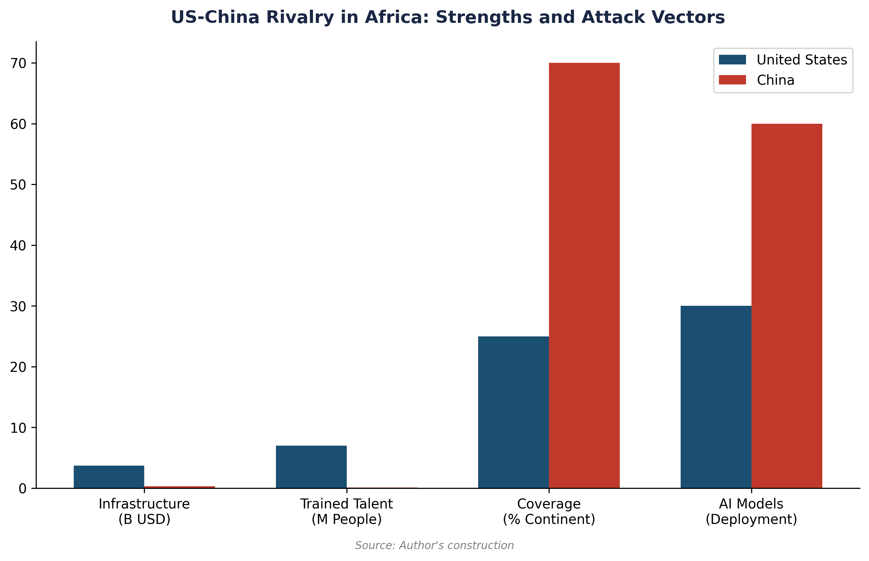

6quater.2.1 China's 'Digital Silk Road'
China is the primary provider of telecommunications infrastructure in Africa (Huawei, ZTE). Through the 'Digital Silk Road', Beijing offers integrated packages including connectivity, data centers, and AI solutions. In April 2026, Huawei is the leader in private cloud infrastructure in more than 20 African countries.[2] For many governments, the Chinese offer is more attractive because it is less restrictive than the American Tier 2 status and often accompanied by preferential financing.


6quater.2.2 The US response: the 'Digital Africa' initiative
The United States seeks to counter Chinese influence through the 'Digital Africa' initiative (part of the PGI), promoting American standards of data governance and security. Microsoft and Google have announced 'AI Centers of Excellence' in Nairobi and Accra.[3] However, US protectionism, by limiting hardware access, paradoxically pushes African actors to accept Chinese hardware, even if they use American software/models.


6quater.3 Synthesis: toward an 'Agentic' or 'Passive' Africa?
The strategic challenge for Africa is to avoid a 'Passive AI' scenario, where the continent remains a simple consumer of American or Chinese models and a provider of training data (task labeling). An 'Agentic AI' scenario requires the development of local compute hubs, the training of local talent (L(r) factor), and the creation of a 'Sovereign African Cloud' to protect data and culture. US protectionism makes this trajectory more difficult but could catalyze regional cooperation within the African Union.
Table 19. Emerging AI hubs in Africa (April 2026).
Source: Author's compilation from African Digital Economy Report.
Country | Primary Hub | Major Actors | Compute Asset | Main Risk
South Africa | Cape Town | AWS, Microsoft, Teraco | Advanced electrical grid (but unstable) | Brain drain to Europe/US
Nigeria | Lagos | MainOne, Medallion, Google | Massive market + young talent | Energy cost + currency volatility
Kenya | Nairobi | Microsoft, Google, Safaricom | Connectivity + mobile fintech leader | Tier 2 import caps
Egypt | Cairo | Orange, Telecom Egypt | Strategic location (cables) + solar | Regulatory complexity

Notes
1. Xalam Analytics (2025), 'The State of African Data Centers'.
2. International Institute for Strategic Studies (IISS, 2025), 'China's Digital Silk Road in Africa'.
3. USAID (2025), 'Digital Africa Initiative Progress Report'.

License and Disclaimer. This work, 'AI for Americans First', is made available under the terms of the Creative Commons Attribution-NonCommercial-ShareAlike 4.0 International (CC BY-NC-SA 4.0) license. You are free to share and adapt the material for non-commercial purposes, provided you properly attribute the work to Fabrice Pizzi (Université Paris-Sorbonne) and distribute your contributions under the same license. This document is provided for educational and research purposes only.
Public Dashboard : https://mo0ogly.github.io/America-First-IA/dashboard/
Repository : https://github.com/mo0ogly/America-First-IA
AI for Americans First - Fabrice Pizzi - Chapter VI quater

